Review of the Literature: Social Media for Travel
Social media's incorporation into the travel and tourism sector has changed how customers look for information, exchange stories, and decide what to buy. The main conclusions from many aspects of this phenomenon are compiled in this evaluation of the literature.
1.1 Conceptual Structures for Acceptance and Utilisation
The Technology Acceptance Model (TAM) is often used in research to explain why travellers use social media to plan their trips. Research demonstrates that perceived utility and perceived usability are key factors influencing usage intentions [2, 5, 7]. This model has been extended by several researches to incorporate perceived trust, social capital, and dispositional readiness, indicating that a traveler's preexisting attitude toward technology affects how beneficial they find social media platforms [5, 7]. Furthermore, the Value-Based Adoption Model (VAM) emphasises that one of the main factors influencing utilisation is a traveler's assessment of "value"—the harmony between advantages and the necessary technological sacrifices [10].
1.2 The Effects of Comparing and Social Influence
Social media is a social environment as much as a tool. The impact of peers' trip posts on behaviour is explained by the Social Comparison Theory. When Millennials are exposed to luxury travel, it can cause benign envy, which in turn makes them more want to travel to those similar places, especially if they have low self-esteem [1]. In a similar vein, the Social Influence Theory proposes that travellers share their personal experiences in order to become socially identified and internalised; this process is frequently motivated by the act of sharing being viewed as enjoyable [8].
1.3 Consumer-Generated Media and Trust (CGM)
Consumer-generated media, such as TripAdvisor reviews, are frequently seen by travellers as less prejudiced and more reliable than traditional marketing [2]. Influenced by the features of the platform, the business, and the user, trust in a social media brand is a crucial precondition for brand loyalty [9]. Those that use CGM for planning are frequently driven by the platform's hedonic value, or enjoyment, even if many users still rely on traditional search [2].
1.4 Strategic Branding and Customer Allegiance
Building a solid social media brand is crucial for developing enduring connections with tourists in the cutthroat tourism industry. In addition to the practical features of the platform, company reputation and customer-specific attributes also contribute to the development of trust in these companies [9]. According to research, social media involvement is a potent motivator of consumer loyalty; in particular, travellers' affective loyalty to travel companies is greatly strengthened by both passive engagement (browsing material) and active engagement (posting and sharing) [6]. This shows that social media is an essential link between initial interest and long-term brand loyalty.
1.5 New Trends: Post-Travel Satisfaction and Age Cues
The significance of demographic-specific marketing has been emphasised by recent studies, especially the part that age cues play in influencer marketing. While younger influencers may unintentionally produce a "contrast effect" that discourages travel among the elderly, older travellers are more likely to develop travel plans when they identify with influencers of a similar age—a process known as assimilation [3]. Additionally, social media has an effect on the post-travel experience in addition to the planning stage. In fact, a traveler's overall happiness can be moderated by the validation they receive from "likes" and comments on their vacation posts, which can sometimes change their pre-travel expectations into a more positive or negative post-travel satisfaction based on peer input [4].

2. Segmented Trends and Demographics
Older Adults: "grand fluencers" have a growing influence on this group. When older travellers identify with similar-aged influencers (assimilation) as opposed to younger influencers (contrast), they exhibit greater travel inclinations [3].
Engagement-Based Loyalty: There are two types of social media interaction: active (posting) and passive (browsing). Affective loyalty to travel brands is strongly influenced by both types [6].
Post-Travel Feedback: Social media has an effect on this stage as well. A traveler's happiness can be moderated by peer reviews and "likes," which might occasionally change their ultimate evaluation of a trip depending on the online validation they receive [4].

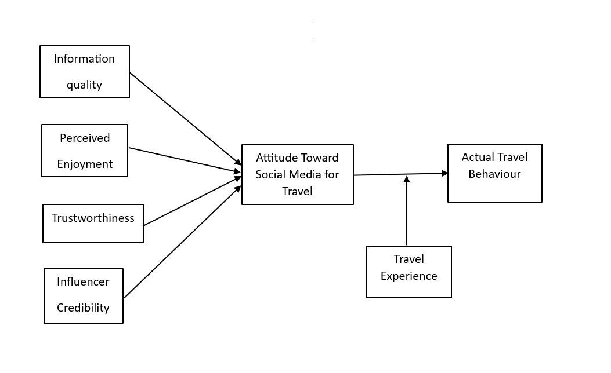

2.2 Research Hypotheses
H1: Perceived usefulness (PU) positively influences the intention to utilise social media for travel.
When travellers think social media will help them plan their trips more quickly and effectively, they are more inclined to use it [2, 5, 7].
H2: There is a positive correlation between the intention to utilise social media for travel and perceived ease of use (PEU).
Travellers are more likely to use a platform for information collecting if it is easy to use and straightforward [2, 7].
H3: Intentions to use social media sites are positively impacted by perceived trust (PT).
High levels of confidence in platform security and user-generated material lower the perceived risk of utilising social media to make important travel decisions [7, 9]
H4: The actual sharing and use of social media is strongly influenced by perceived enjoyment (hedonic value).
Social media's "fun" feature serves as a mediator; people exchange content or look up information because it's an enjoyable procedure [8, 10].
H5: The association between travel experience and traveller happiness is moderated by social influence and peer validation (e.g., "Likes").
A traveler's reported satisfaction and post-trip confirmation can be increased by positive feedback from a social network [4, 8].
H6: Seeing other people's travel experiences causes benign jealousy, which raises inclinations to visit a destination.
Millennials in particular are motivated to duplicate the luxury trip experiences they witness in similar peers' posts [1].
H7: Travel intention is positively impacted by influencers and travellers having similar ages (Age Cues).
When older persons identify with influencers of a similar age, they are more likely to travel to certain places (assimilation effect) [3].
H8: Brand loyalty is positively impacted by both active and passive social media participation.
Stronger emotional (affective) and behavioural (conative) loyalty to travel companies is correlated with higher levels of involvement with travel-related information [6, 9].

List of References
[1] Liu, H., Wu, L., & Li, X. (2018). Social Media Envy: How Experience Sharing on Social Networking Sites Drives Millennials' Aspirational Tourism Consumption. Journal of Travel Research, 1-15.
[2] Ayeh, J. K., Au, N., & Law, R. (2013). Predicting the intention to use consumer-generated media for travel planning. Tourism Management, 35, 132-143.
[3] Leung, X. Y., Zhong, Y. S., & Sun, J. (2025). The impact of social media influencer's age cue on older adults' travel intention: The moderating roles of travel cues and travel constraints. Tourism Management, 106, 104979.
[4] Sedera, D., Lokuge, S., Atapattu, M., & Gretzel, U. (2017). Likes - the key to my happiness: The moderating effect of social influence on travel experience. Information and Management, 54(6), 825-836.
[5] Kathuria, S., Tandon, U., Ertz, M., & Bansal, H. (2020). Social vacation: Proposition of a model to understand tourists' usage of social media for travel planning. Manuscript.
[6] Van Asperen, M., de Rooij, P., & Dijkmans, C. (2017). Engagement-based loyalty: The effects of social media engagement on customer loyalty in the travel industry. International Journal of Hospitality & Tourism Administration.
[7] Singh, S., & Srivastava, P. (2019). Social media for outbound leisure travel: A framework based on technology acceptance model (TAM). Journal of Tourism Futures, 5(1), 43-61.
[8] Kang, M., & Schuett, M. A. (2013). Determinants of sharing travel experiences in social media. Journal of Travel & Tourism Marketing, 30, 1-15.
[9] Christou, E. (2015). Branding Social Media in the Travel Industry. Procedia - Social and Behavioral Sciences, 175, 607-614.
[10] Chung, N., & Koo, C. (2015). The use of social media in travel information search. Telematics and Informatics, 32, 215-229.

